Pls. find the final output link:--

<http://ec2-35-182-19-6.ca-central-1.compute.amazonaws.com:8080/SpringMVCloginExample/login>

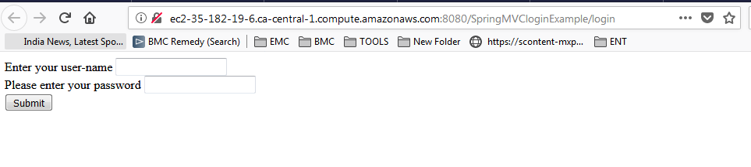

* User Name:--Ram
* Password:--rampathak

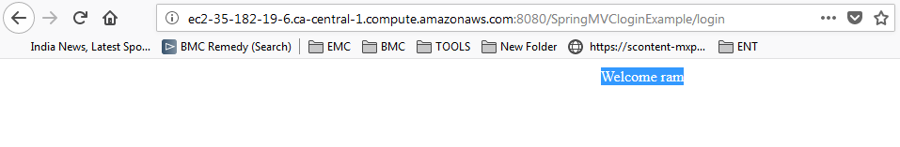

Pls. find the VPC status:--

